**TECHNICAL REPORT**

**AIML FOR NETWORKING**

**TEAM NAME: ENCRYPTO KNIGHTS**

**TEAM MEMBERS: 3**

**Problem Statement**

Modern networks face increasing challenges in monitoring and securing traffic due to the exponential growth of data, encrypted communication, and sophisticated cyber threats. Traditional rule-based security measures and deep packet inspection (DPI) techniques are becoming less effective in detecting and classifying threats, especially in encrypted traffic. Manual intervention in network traffic classification is inefficient, leading to delayed threat detection and security vulnerabilities. To address these issues, Al-driven solutions can analyze traffic patterns, detect anomalies, classify applications, and enhance security in real-time, ensuring adaptive and intelligent network defence.

**Abstract**

Our project focuses on developing a machine learning-based system to detect phishing websites through URL analysis. Various classification models were explored and evaluated to identify the most effective approach for accurate prediction. The system is integrated into a user-friendly web application built with Streamlit, allowing real-time detection of suspicious URLs. By analyzing structural patterns, domain information, and other URL-based indicators, the application helps users determine whether a given link is legitimate or potentially malicious. This solution aims to support internet safety by offering a quick, accessible, and reliable tool for phishing threat identification.

**Introduction**

Phishing is a widespread cyber threat where attackers trick users into revealing sensitive information through fake websites that closely resemble legitimate ones. These fraudulent websites are often accessed via deceptive URLs sent through emails, social media, or messaging platforms. Identifying such malicious links before users interact with them is crucial to improving online safety.

It aims to develop an intelligent URL-based phishing detection system using machine learning techniques. By analyzing various characteristics of URLs — such as their structure, domain information, SSL certificate status, and DNS validity — the system can effectively classify whether a given URL is legitimate or potentially harmful. Multiple machine learning models were evaluated to determine the most accurate and efficient one for this task.

To make the system accessible and easy to use, a Streamlit-based web application was developed. It allows users to input any URL and instantly receive a prediction, enhancing real-time threat detection. This project demonstrates the power of combining machine learning with real-time feature extraction to combat phishing attacks and protect internet users from falling victim to online scams.

**Architecture Diagram**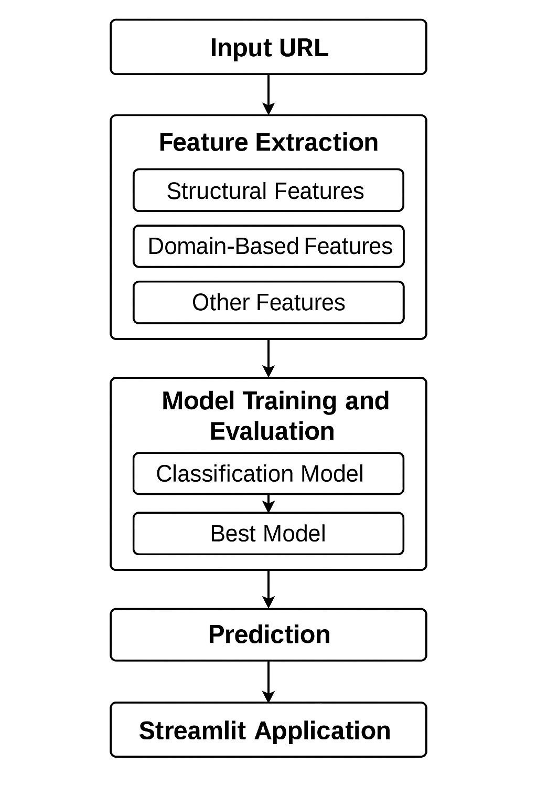

**Work Flow**

1. **User Input (Frontend)**
   * User enters a URL into the Streamlit web app.
   * Clicks “Predict” button.
2. **Feature Extraction (Backend Processing)**
   * The system parses the URL using urlparse(), re, and other standard libraries.
   * It generates 16 features including:
     + Structural features (length, depth, special characters)
     + Domain features (WHOIS domain age, expiration)
     + SSL status
     + DNS resolution
   * Some features are fetched live (e.g., WHOIS, DNS, SSL check).
3. **Model Loading**
   * A pre-trained ML model is loaded from XGBoostClassifier.pickle.dat using pickle.
4. **Prediction**
   * The extracted feature vector (length 16) is passed into the model’s .predict() method.
   * The model outputs a prediction: 0 (Legitimate) or 1 (Phishing).
5. **Result Display (Frontend)**
   * Based on prediction, the app shows:
     + 🟢 “Legitimate” for 0
     + 🔴 “Phishing” for 1

**Optional Control Paths**

* **Error Handling**:
  + If feature extraction fails or whois/DNS times out → default fallback values are used.
* **Input Validation**:
  + If the user enters an invalid or empty URL, the app prompts them for valid input.

**Analysis**

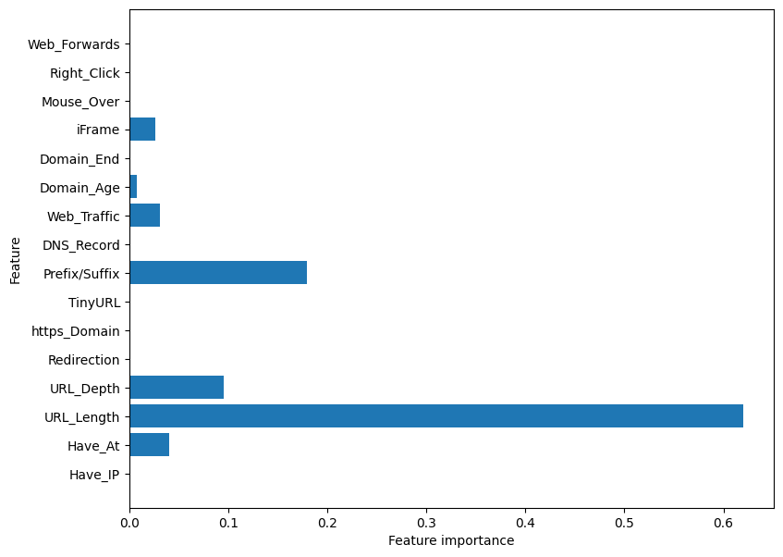

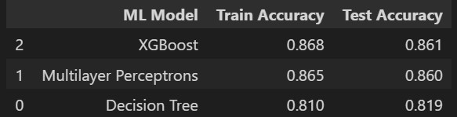

We experimented with three different machine learning models to detect phishing URLs: **XGBoost**, **Multilayer Perceptron (MLP)**, and **Decision Tree**. We trained each model on the same dataset and compared their performance using both training and testing accuracy.

Among the three, **XGBoost performed the best**, with a training accuracy of **86.8%** and a test accuracy of **86.1%**. This means it not only learned the patterns in the training data well but also made accurate predictions on new, unseen data — which is exactly what we want from a reliable model.

The **Multilayer Perceptron** came very close, achieving **86.5%** training accuracy and **86.0%** on the test data. This shows that neural networks can also work effectively for this type of classification task, though they may require more computational resources and fine-tuning.

On the other hand, the **Decision Tree** model showed a noticeable gap in performance. Its training accuracy was **81.0%** and test accuracy was **81.9%**. While it's easy to implement and interpret, it didn’t perform as well as the other two, likely because it couldn't capture complex patterns in the data.

Overall, based on the accuracy scores and stability across both training and testing sets, we selected **XGBoost** as the final model for integration into our phishing detection web application.

**Contribution**

**Person 1 (Koushik Maharushi): Model Development**

**Responsibilities:**

* Data preprocessing and cleaning
* Feature engineering (e.g., URL parsing, WHOIS info, SSL checks)
* Train and compare machine learning models (XGBoost, etc.)
* Evaluate models (accuracy, precision, recall, etc.)
* Save the final trained model as a .pickle file

**Deliverables:**

* model_training.ipynb or train_model.py
* XGBoostClassifier.pickle.dat
* Documentation of model selection and performance

**Person 2 (V. Sreeja): Streamlit App Developer**

**Responsibilities:**

* Design and build the Streamlit app (app.py)
* Implement real-time feature extraction from input URLs
* Integrate model predictions into the app
* Handle exceptions, validation, and result display

**Deliverables:**

* app.py
* Functional UI with input → prediction flow
* Error handling and validation logic

**Person 3 (S. Vennela): Deployment & Documentation**

**Responsibilities:**

* Prepare and organize project structure for deployment
* Create and test requirements.txt
* Deploy the project on Streamlit Cloud (or locally)
* Write project report: abstract, introduction, architecture, etc.
* Create visuals: architecture diagram, flowcharts, control flow

**Deliverables:**

* requirements.txt
* GitHub repo with all files
* Final project report / documentation

**Result**

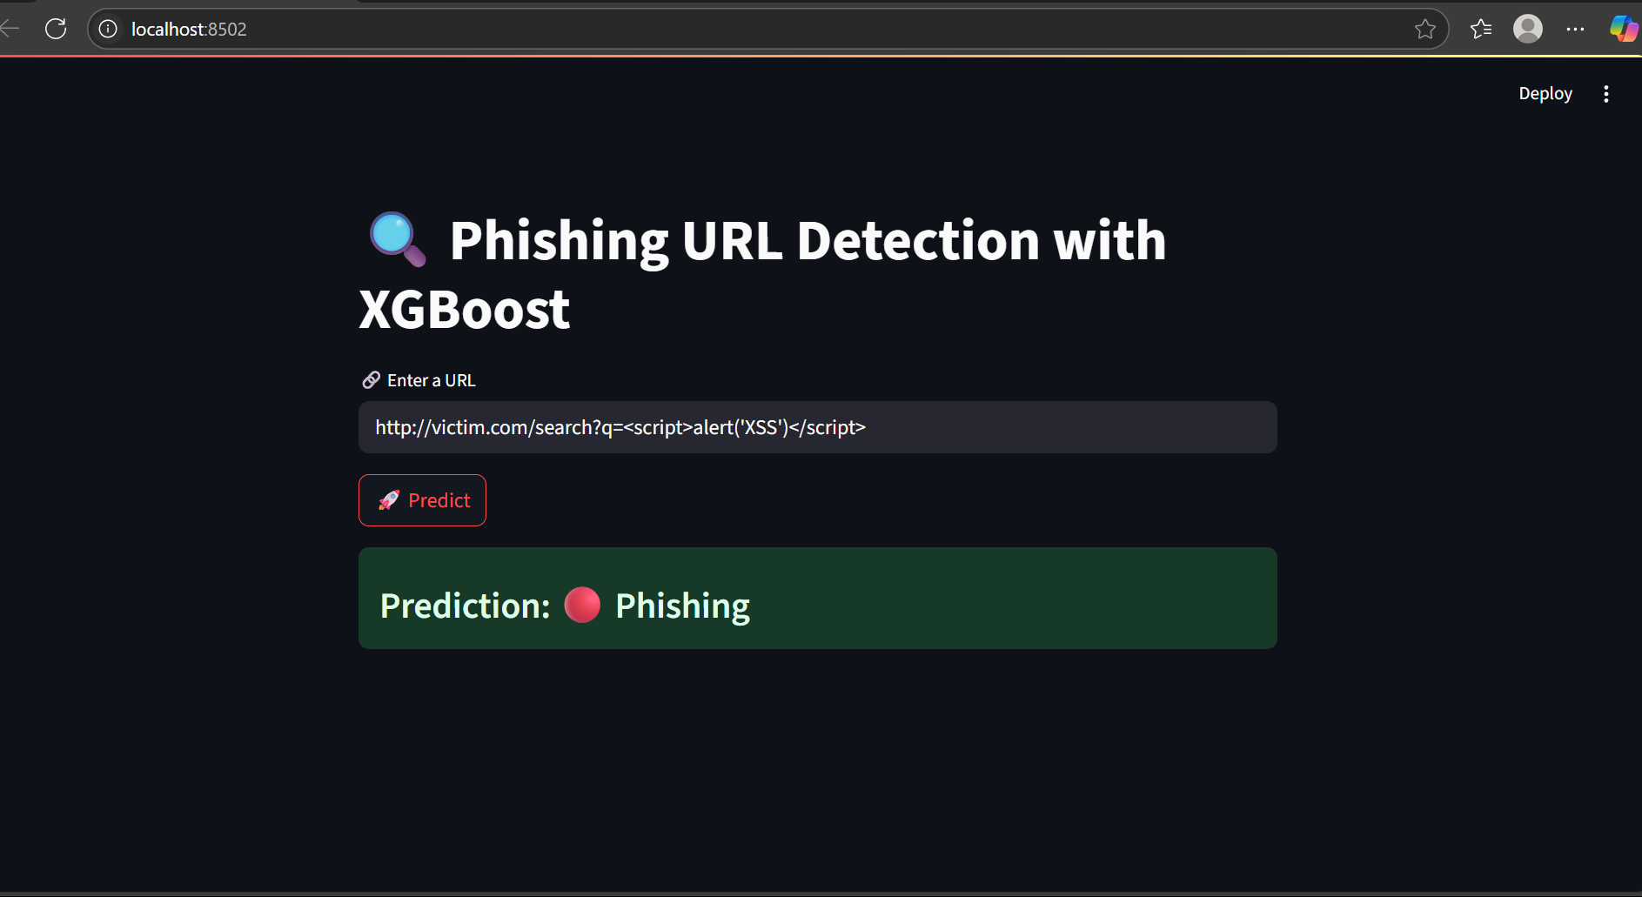

**Fig 1**: Displaying of Phishing Website

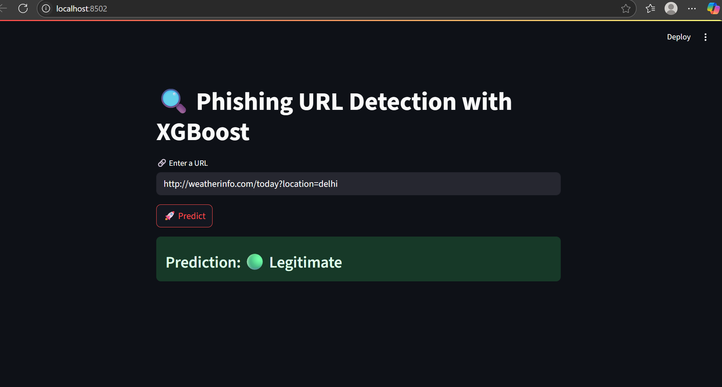

**Fig 2**: Displaying of Legitimate Website

**Links of the result:**

Result model link: <https://drive.google.com/file/d/1kGU12jrPp37lHjCTQihXkZcgQntIGEtD/view?usp=drive_link>

GitHub link: <https://github.com/Koushik-Maharushi/IntelUnnatiInternship>